Learning git and github

I will start with definition of both and difference between them:

**Git**-It was 1st created by linus torvalds in 2005.it is free and open source control system.

It is not centralized like other control system, it is distributed version of control system designed to handle small to large project with efficiency.

It help in coordination between programmers.

**Github**-It is git repository hosting service but with many extra features of its own. Basically it is an American multinational corporation that provides hosting for software development and version control using git.

**Difference between git and github**

|  |  |
| --- | --- |
| gitGit_icon.svg.png | githubdownload.png |
| It is distributed version control system which tracks changes to source code over time. | It is web hosting service for git repository to bring developer together. |
| Command line tool that requires an interface to interact with world. | Graphical interface and development platform |
| Creates a local repository to track changes locally rather than store them on centralized server. | It is open source which means code is centralized server and is accessible to everybody. |
| Git can work without GitHub as other git repositories are also available. | Alternative of github are GitLab and BitBucket |

Now to use github first of all we need to register for github account

For that go to <https://github.com/>

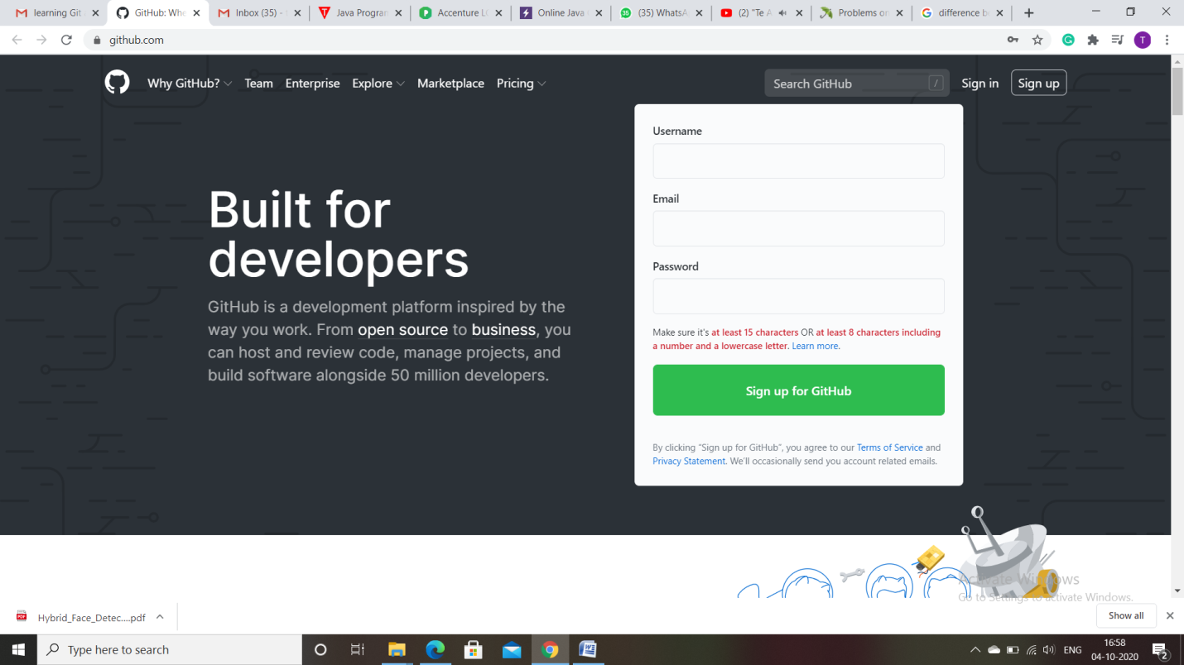

Signup to register your account.

Now install git client in your system,for that go to url <https://git-scm.com/download/gui/windows>

Based on your operating system download any of the gui for your system

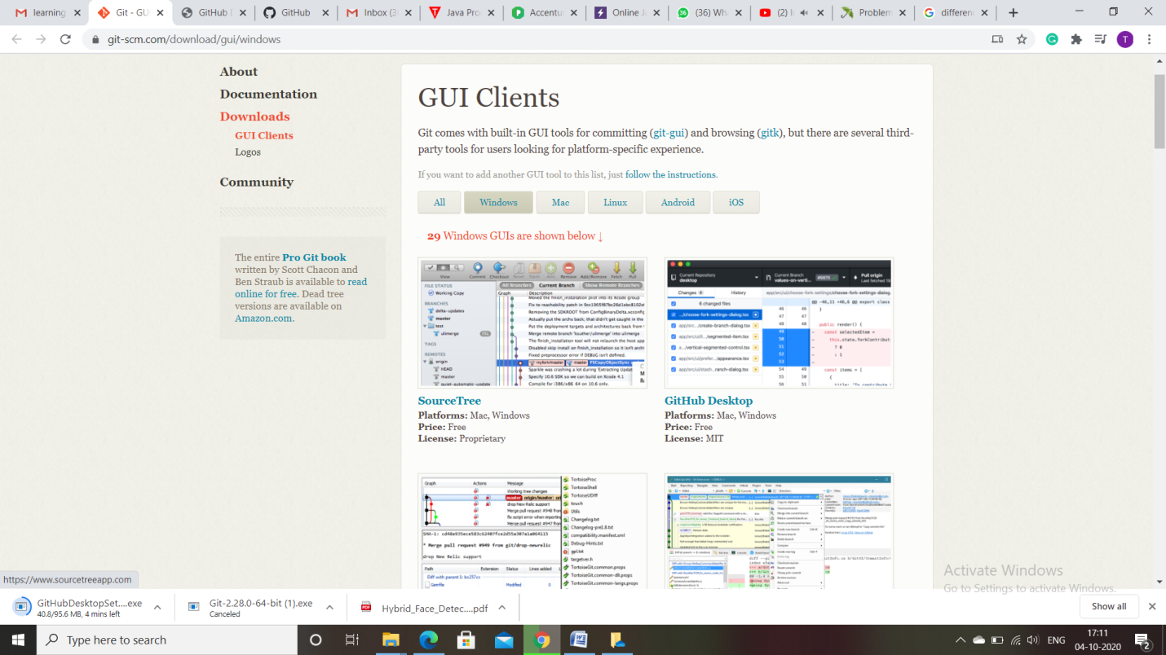

I installed Github desktop

Now after installation login to your github client software using github id.

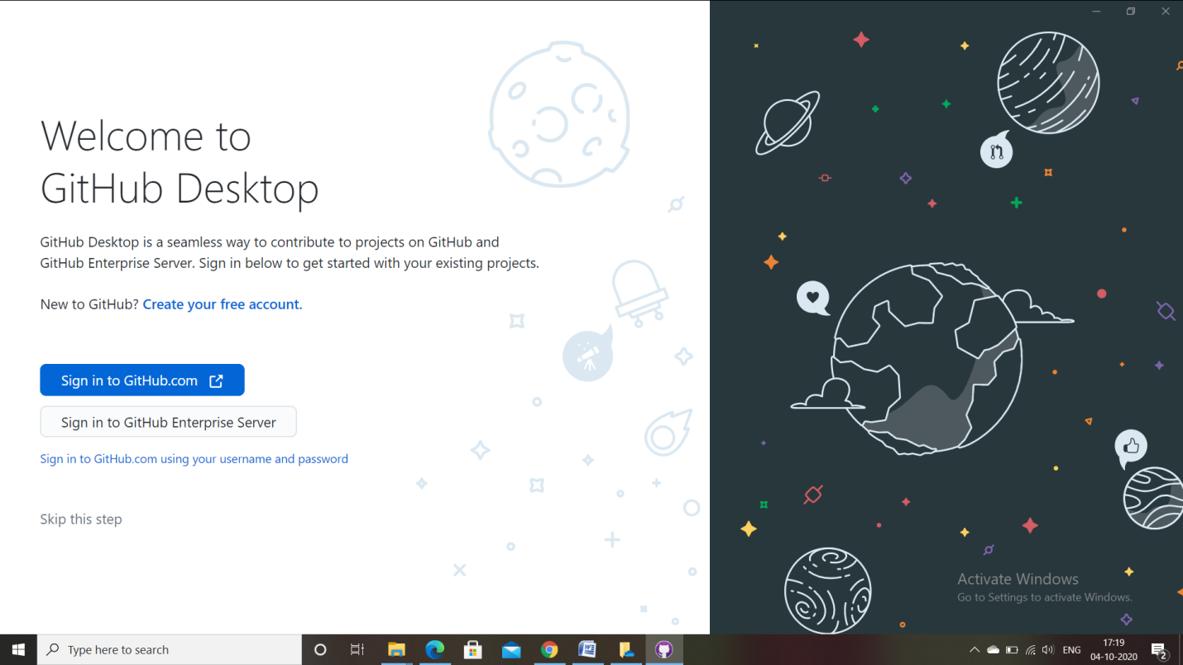

Now lets start with making git repository but before that let i give you brief about repository.

**Repository** is a git project that is entire collection of files and folders related to project and also with each file revision history.

Create a new repository

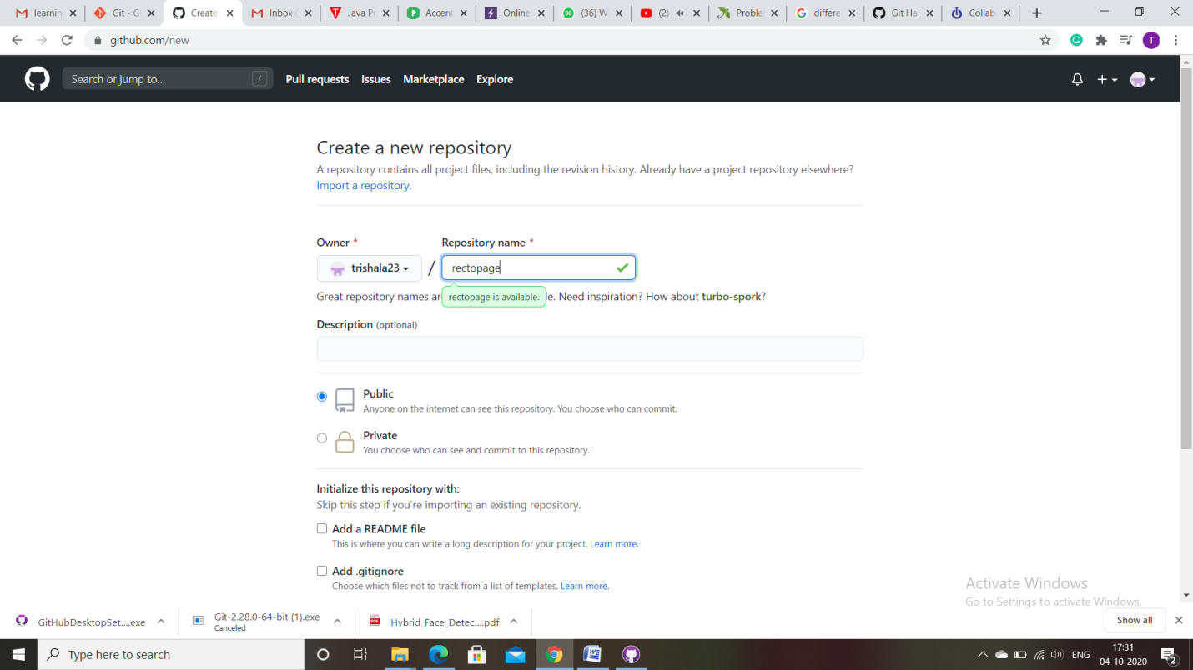

Now give collaborator as **rectopage.india@gmail.com**

One person will be the “Owner” and the other will be the “Collaborator”. The goal is that the Collaborator add changes into the Owner’s repository. We will switch roles at the end, so both persons will play Owner and Collaborator.

Owner need to give access to colabrator

Steps for giving collabrator:

* Click on the setting button

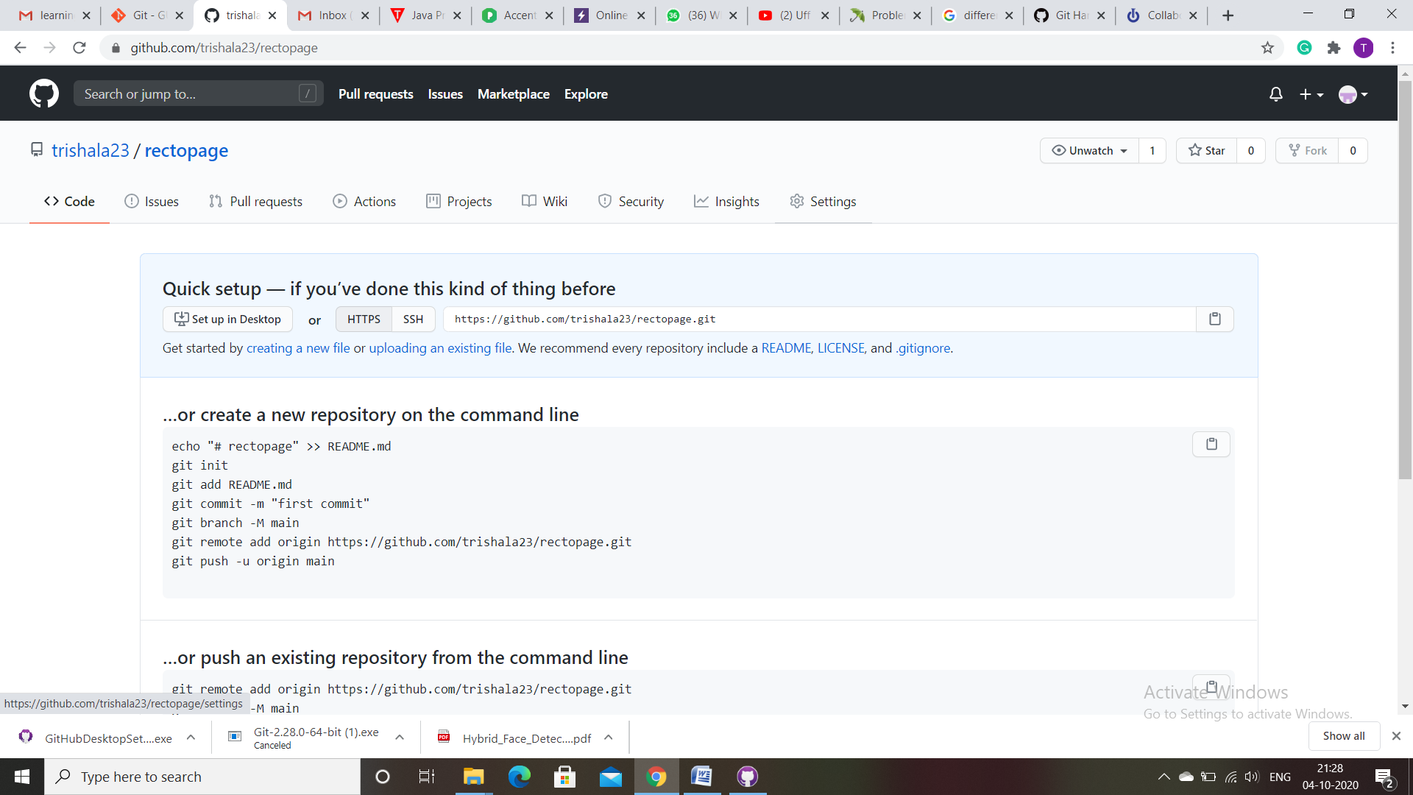

* After that select manage access at the left

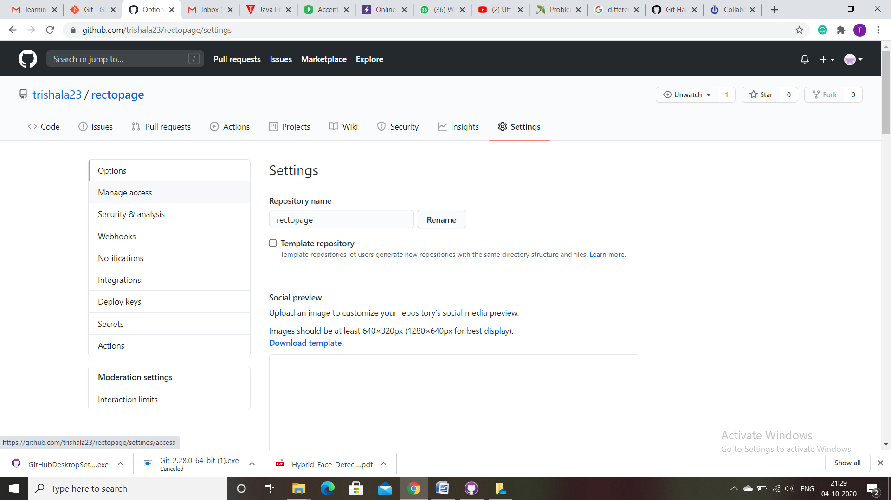

* Then select invite a collaborator

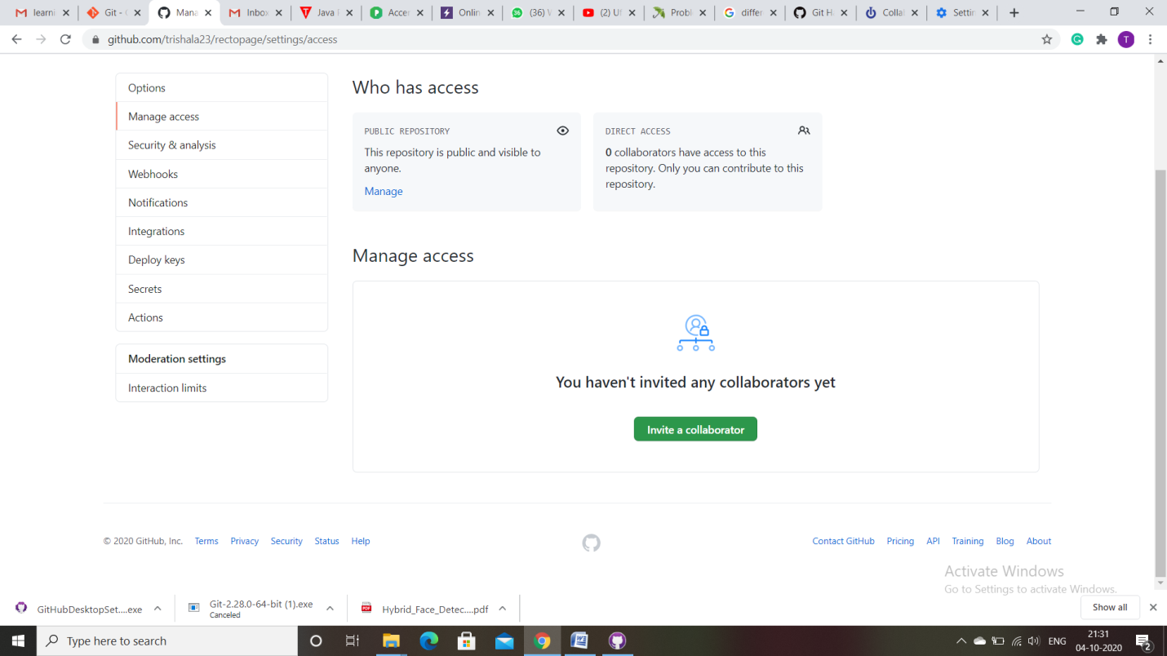

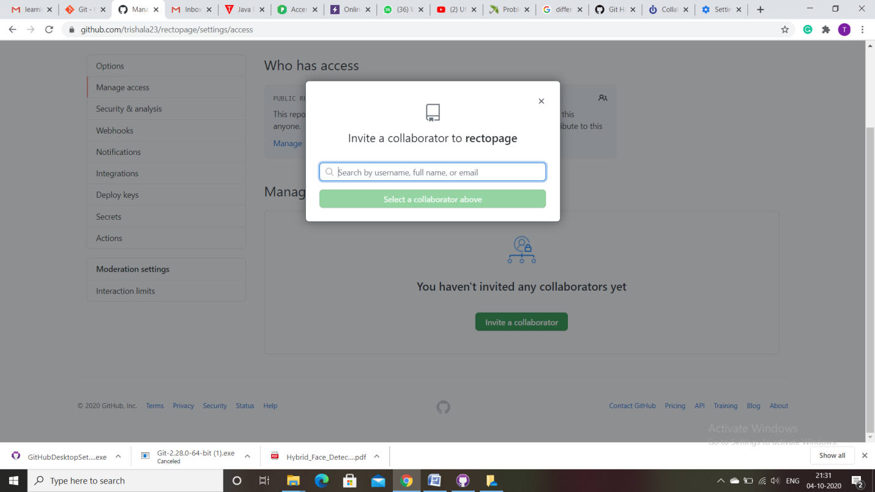

* Now give the mail id of rectopage and invite as collaborator.

There are various Commands in github. Some most used commands are:

* **Git Init:** It initializes a new repository and tracks a existing repository. This command turn the directory as empty git repository

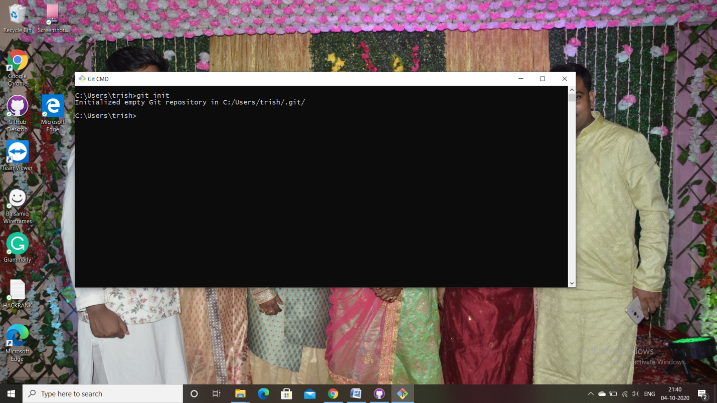

Git clone: it is used to create a local copy of existing working repository.this includes all project files,branches etc.

Copy the repository url and paste that after git clone command

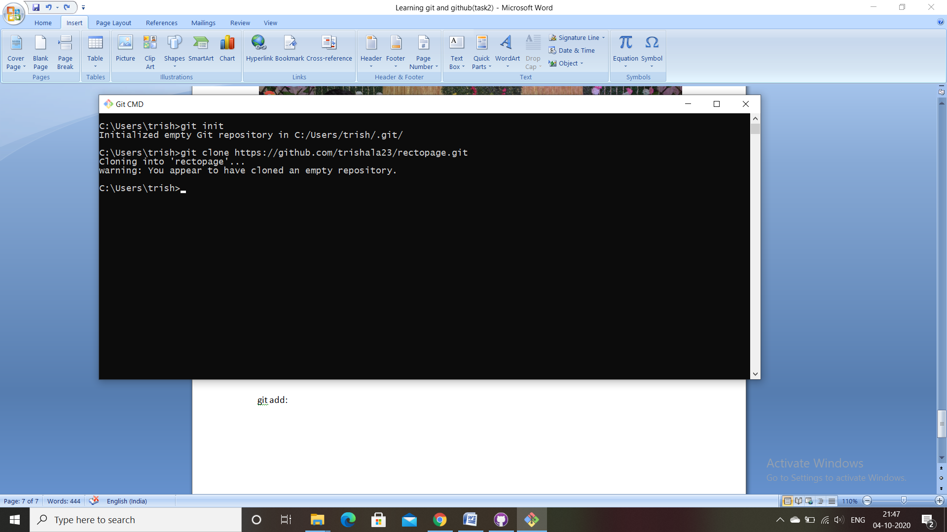

* **git add**: This command adds the files in the index area of git. Before committing files need to be added to index.

Syntax: git add <file or directory name>

Also to add all files not staged use git add .

* **git commit**: It will create a snapshot of the changes and save it to the git directory.

Syntax:- git commit –m “message”

* **git status:** It displays the list of changed files together with the files that are yet to be staged or committed.
* **git push: It** is used to send local commits to the master branch of the remote repository

Syntax: git push origin<master>

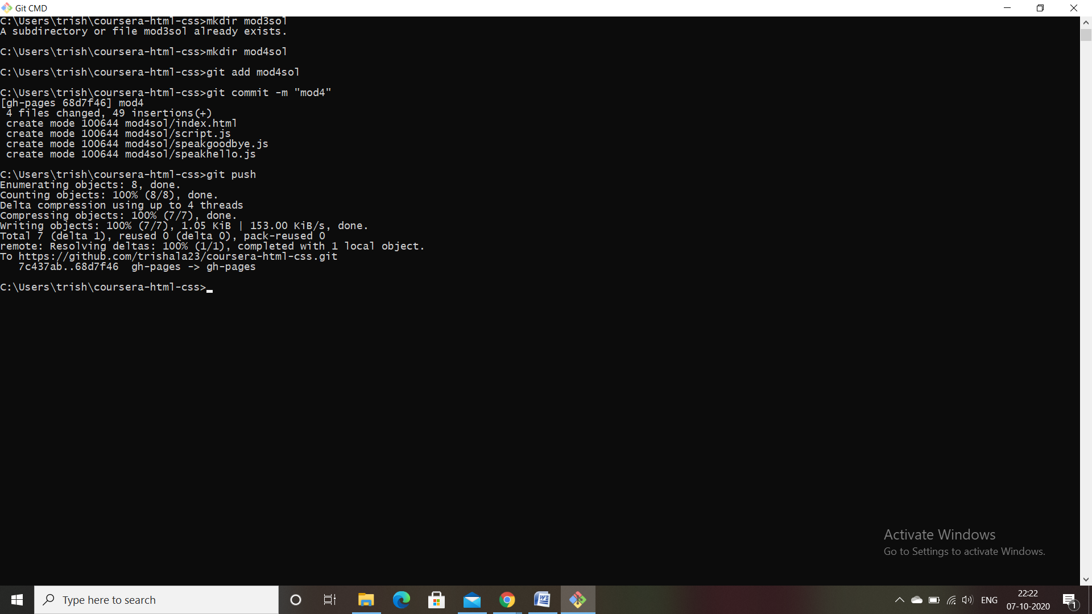

* **git branch**: It will list, create, or delete branches.

For listing branches,command should be git branch

For deleting branch command should be git branch –d <branch-name>

* **git pull** : It merges all the changes present in the remote repository to the local working directory.
* **git merge:** It is used to merge a branch into the active one.

Syntax-git merge <branch-name>